Senior Design Documentation

* Angular
* Angular CLI
* Github
* Node JS

Angular-CLI

Install:

***NPM Required***

npm install -g angular-cli

Where:

You have to go to your local machine terminal and input the following command

(npm install -g angular-cli ).

How we use it:

ng new Project_Name - - - - - Creates new angular project

ng serve - - - - - This command compiles and serves the app

GitHub

Install:

You can install the desktop version of github from <https://desktop.github.com/> or just use the website. You must be invited to our repo and once you receive that invitation accept and our repo should be available for you to access.

Where:

We primarily use github in our WebStorm IDE. In WebStorm we can directly interact with our repo.

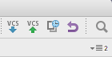

( Blue arrow is a pull from our repo and the green arrow is to push something to the repo)

How we use it:

We use GitHub to bring all the work of the team together. There are a couple steps in how we use the repo for our project.

1. When you open WebStorm you have the option use a repo for to open a project and choose GitHub

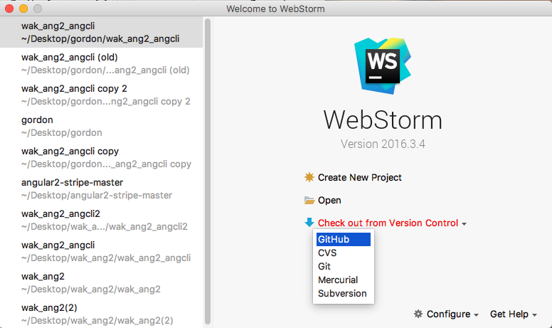

(2) After you clicked GitHub there will be a option for a what repo you would like to use make sure you select the one for the Gordon Water System.

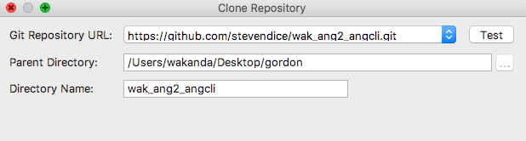

(3) After that you have set up the project in WebStorm has now been set up to use GitHub.

(4) When you make any changes and want to update the repo you must first pull down the repo and rebase then select the files you changed and leave a message.

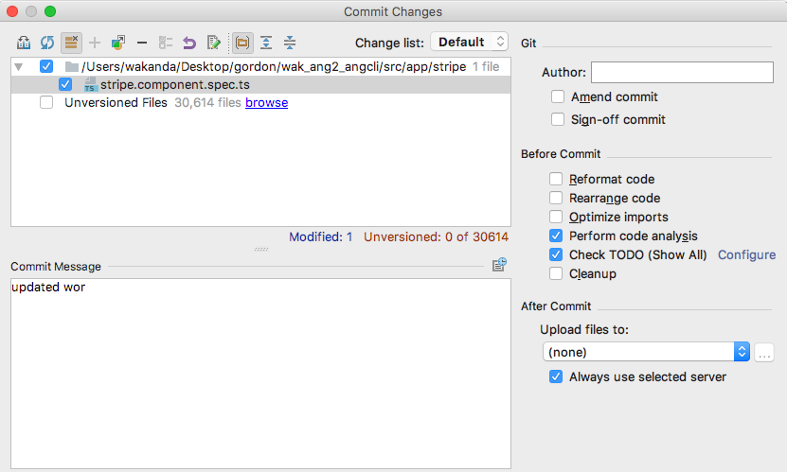

Node JS

Install:

**npm install npm@latest -g**

Where:

You would first do this step in your local machine terminal

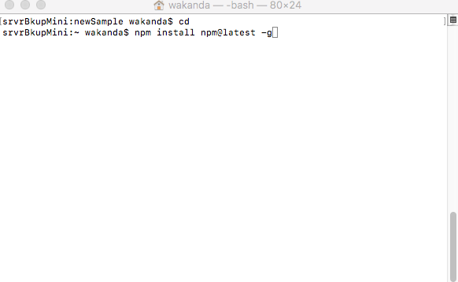

router.get(**'/cof'**, (req, res) => // This is the address we go to retrieve the data on the angular side

// But understand that this really means “api/cof” because we are in the api folder.

*// Get posts from the mock api*

*// This should ideally be replaced with a service that connects to MongoDB*

**axios**.get(**`**${API}**/posts`**) //This is the rest api that we use to bring data into our node js server

.then(**posts** => {

**res**.status(200).json(**posts**.**data**); // if there is no error then post json data to “api/cof”

})

.*catch*(error => {

**res**.status(500).send(***error***) // if there is error then console error

});

});

How we use it:

This is a package manager we use this to add new packages to our node modules. For example we needed to install ag-grid into our node modules we ran the following command in WebStorm.